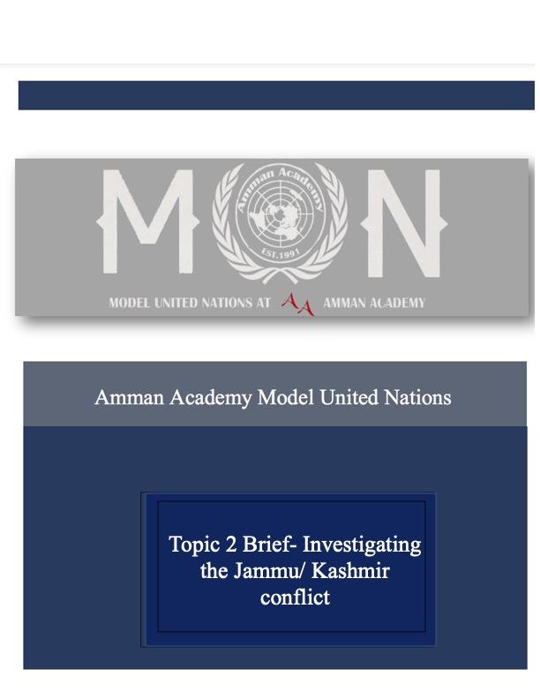

Commission on the Status of Women – Topic 3 Creating a Safe and Equal Working Environment for Women

**Introduction:**

The Commission on the Status of Women (CSW) is the principal global intergovernmental body exclusively dedicated to the promotion of gender equality and the empowerment of women. A functional commission of the Economic and Social Council (ECOSOC), it was established by ECOSOC resolution 11(II) of 21 June 1946.

The CSW is instrumental in promoting women’s rights, documenting the reality of women’s lives throughout the world, and shaping global standards on gender equality and the empowerment of women.

Women are faced with unfair working conditions regardless of where they find themselves in, this primarily found through issues regarding sexual harassment, among other forms of sexual violence, in the workspace. In general, the workforce is predominantly male, due to the late introduction of women into it, which creates leeway for female targeted harassment. Women are affected by this that they no longer feel safe in their own workplaces and that is the exact issue this committee aims to tackle- delegates who find themselves allocated here are to search for solutions to diminish the issue from its core, all while staying committed to their foreign policies.

**Definition of Key Terms:**

* Sexual violence:

The term ‘sexual violence’ is defined as Aay sexual act, attempt to obtain a sexual act, unwanted sexual comments or advances, or acts to traffic or otherwise directed against a person’s sexuality using coercion, by any person regardless of their relationship to the victim, in any setting, including but not limited to home and work.

* Femicide:

Intentional homicides of female victims committed. by intimate partners, those committed by other family members and those committed by others.

* Feminism

The belief that men and women should have equal rights and opportunities." It encompasses social, political and economic equality.

* Patriarchy:

A hierarchical-structured society in which men hold more power.

* Sexism:

The idea that women are inferior to men.

* Misogyny:

Hatred of women.

* Gender equality:

The concept that women and men have equal conditions, treatment and opportunities for realizing their full potential, human rights and dignity, and for contributing to (and benefitting from) economic, social, cultural and political development.

**General Overview:**

A current unfortunate ongoing conflict in many countries is sexual harassment, and other forms of sexual violence. Different types of sexual violence against women and girls are experienced and feared in work settings, ranging from unwanted sexual comments and gestures to rape and femicide. This could cause some women to feel unsafe in the workplace environment, and therefore, the committees main goal is to create a safe and equal working environment for women.

With continuous trends in the increase of violence upon women in workplace environments, we will date ourselves back to the early 20th century where women had no rights, including no right to work. Improved protections must be put into place, including preventive measures, to facilitate and safeguard women’s safety in the workplace environment. If they are not, many hard-fought gains for women's rights around the world could be in jeopardy.

**Parties Involved:**

- Japan:

Japan is one of the world's most innovative and technologically sophisticated countries yet has traditional gender norms and is prone to exerting pressure on people who do not fit those expectations. Voicing issues or publicly stating one's views is typically not welcomed by the general public. Challenging the established quo requires courage from Japanese women, but additionally might have negative consequences for their personal and professional lives. Despite the fact that female empowerment and activist organizations are becoming more popular in Japan, only a small fraction of the population identifies as feminists. Women most prevalently face this issue in their work field. Another issue related to the quantity of unpaid labor carried out by women according to the survey of respondents in Japan. Although these two impediments were deemed by 48% to be the most severe, about 40% of the people in Japan have identified sexual assault and sexual harassment as their primary concern.

- India:

Violent groups, frequently being violent mobs affiliated with competing political parties, no frequently target women who support political parties in India. For instance, on July 22, 2021, two women were allegedly injured when members of the Trinamool Congress Party's (TMC) women's wing were allegedly attacked by members of the government's Bhartiya Janata Party (BJP) outside of Cooch Behar town. As the nation prepared for its general election in 2019, violence against women in politics reached its height. Both the overall voter turnout and the percentage of women voters in that election were record-high. As a result, even though such targeted violence has since decreased, India continues to be one of the most violent nations in the world for women in politics, and the threat of such violence is still very real in the run-up to upcoming elections, like the upcoming assembly elections starting next month.

- Brazil:

In Brazil, attacks on female candidates for public office are frequent, particularly in the run-up to elections. These attacks are often carried out by unidentified armed operatives looking to sway local politics and acquire access to lucrative criminal activity. For instance, on August 30, 2020, drug traffickers murdered a candidate for the city council (PSB) in Mage, Rio de Janeiro, and dumped her body into a river. The murder was caused by the candidate's promises to report local drug trafficking if elected. Prior to the 2020 November municipal elections, there had been an increase in this type of targeted violence in Brazil. A new rise in violence is likely to occur before the general election later this year.

- United States:

Approximately one in four (30 million) American women and men have experienced physical abuse, stalking, or sexual assault at the hands of an intimate partner at some point in their lives. Through the years, The United States has made significant strides in addressing violence that many women endure. Threats to women’s working environment have a huge impact upon their economic security, health, civic engagement, and general well-being despite the progress to help tackle the issue. According to a 2018 survey by Stop Street Harassment, alarmingly 81% of women and 43% of men had experienced harassment in their lifetime. 38% of the 996 women respondents reported experiencing job harassment.

- Columbia:

In Colombia, women activists, human rights advocates, and social leaders are at greater risk due to frequent attacks carried out by unidentified armed attackers. For instance, on September 23, 2021, three armed unidentified individuals killed an indigenous woman in Jambalo, Cauca department, who was a leader in her community. Violence against women in workforce continues in Colombia from 2019 to 2020 and rose from 2020 to 2021, indicating an increasing cause for concern.

**UN Involvement:**

Leading women's organizations, local and national governments, UN agencies, and other partners have been working with UN Women's global initiative Safe Cities and Safe Public Spaces for Women and Girls for the past ten years. This practice was placed in order to develop and evaluate comprehensive strategies to prevent and address sexual harassment against women and girls in public spaces in various settings. The UN also promotes Gender Equality, as it is listed as one of the Sustainable Development Goals (SDGs).

**Possible Solutions:**

1. Redrafting governmental systems to improve access to good quality health, social welfare, and criminal justice support services for all woman who need them, including reporting any assault or harassment case, with the suggestion of projects to develop,
2. Demands that all countries enact strict laws and legalities, which includes legislate consequences for any patriarchal behavior and providing healthcare for women in need,
3. Develop and effectively implement comprehensive laws and policies to prevent and respond to sexual violence in public spaces,

**Bibliography:**

<https://unstats.un.org/unsd/statcom/53rd-session/documents/BG-3j-Crime&CriminalJusticeStats-E.pdf>

<https://apps.who.int/iris/bitstream/handle/10665/77434/WHO_RHR_12.37_eng.pdf>

<https://www.nsvrc.org/sites/default/files/publications_nsvrc_overview_sexual-violence-workplace.pdf>

<https://www.unwomen.org/en/digital-library/publications/2018/12/fourth-un-women-safe-cities-and-safe-public-spaces-global-leaders-forum>

<https://www.ilo.org/wcmsp5/groups/public/@dgreports/@gender/documents/publication/wcms_105060.pdf>

<https://www.unwomen.org/sites/default/files/Headquarters/Attachments/Sections/How%20We%20Work/flagship%20programmes/UN-Women-Flagship-programme-Safe-cities-public-spaces-en.pdf>

<https://www.usatoday.com/story/news/2017/03/16/feminism-glossary-lexicon-language/99120600/>

<https://www.unicef.org/rosa/media/1761/file/Gender>

<https://www.workplacesrespond.org/resource-library/facts-gender-based-workplace-violence/>

<https://www.nsvrc.org/sites/default/files/publications_nsvrc_overview_sexual-violence-workplace.pdf>

<https://statusofwomendata.org/explore-the-data/violence-safety/>

<https://inspiredelearning.com/blog/sexual-harassment-in-the-workplace-statistics/>

<https://www.unwomen.org/en/what-we-do/ending-violence-against-women/creating-safe-public-spaces>